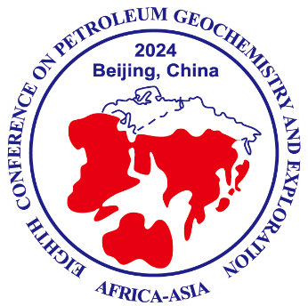
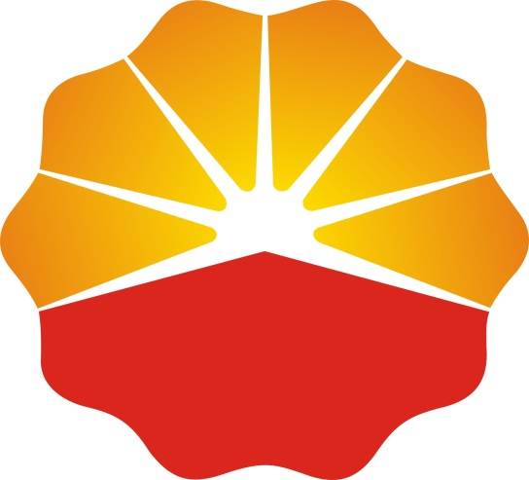

The 12th International Conference on Petroleum Geochemistry and Exploration in the Afro-Asian Region
SECOND CIRCULAR
AAAPG 2024
October 18-19, 2024
Beijing, China
www.aaapg.org.cn

The 12th International Conference on Petroleum Geochemistry and Exploration in the Afro-Asian Region (AAAPG2024) is an international forum where the latest research and technological advances related to petroleum geochemistry in the Afro-Asian region are presented and exchanged. This is the 12th meeting of the AAAPG series which started in 1985 to unit experts in petroleum geochemistry across the Afro-Asian region, working on various geological and geochemical issues. The objective of the AAAPG 2024, which is to be held in Beijing, China, on 18-19 October, 2024, is to promote international and interdisciplinary exchange of information, to foster co-operation among researchers in academia, research institutes and industries, and to stimulate growth and advances in the field of petroleum geochemistry across the Afro-Asian region.

CONFERENCE THEME: New advances of petroleum exploration & exploitation in Afro-Asian region and coordinated development of regional resources and environment

Scientific topics:
1. Evolution of multiple layers of the Earth and carbon cycling
2. Fossil fuel resources of Afro-Asian region & exploration priorities
3. Geochemistry of oil and gas generation and reservoir formation
4. Conventional and unconventional integration system of petroleum
5. Generation and evolution of Deep and ultra-deep reservoirs
6. Biomarkers and isotope organic geochemistry
7. Biological and Environmental Organic Geochemistry
8. Novel geochemical experimental techniques and methods
9. Digital earth and Intelligent Geochemical Exploration
10. Exploration and Comprehensive Utilization of petroleum Associated Resource (H₂, He etc.)
1. Organization
HOST: Afro-Asian Association of Petroleum Geochemists (AAAPG)
Chinese Petroleum Society, Geological Professional Committee
Geology Society of China, The Professional Committee of Petroleum Geochemistry and Accumulation

ORGANIZER: Research Institute of Petroleum Exploration and Development (RIPED)
State Key Laboratory of Enhanced Petroleum Recovery (SKL-EPR)
Key Laboratory of Petroleum Geochemistry (KLPG) of CNPC

Date and Venue:
The conference will start in Beijing, China and the proposed date is 18-19 October 2024, including 2-days meeting and followed by a 1-day field trip.
The Venue of conference and accommodation is CNPC Scicence-Technology Exchange Center, which located at the Northeast corner of intersection of Huanghe Street and Taihang Road, Changping District, Beijing.

2. Registration
Important Dates:
May 20, 2024: Registration and Abstract Submission open
July 20, 2024: Abstract Submission deadline
July 30, 2024: Abstract Acceptance Notification, and send invitation for Visa application
August 31, 2024: Early bird registration and reservation
October 17, 2024: On-site registration and conference icebreaker (evening)
October 18-19, 2024: Conference sessions (3 days)
October 20, 2024: Conference fieldtrips (optional)

ABSTRACT SUBMISSION:
All participants are invited to submit an abstract of one page in length. Official language is English. Abstracts must be in Microsoft Word format only through the abstract template with at most one figure or table, and shall be sent in electronic form no later than July 20th 2024. Abstract template can be downloaded from the congress homepage http://www.aaapg.org.cn. Abstracts shall also be submitted through above Website.
Early bird Registration fees：
 | National | International
Industry / Academia: | ￥2500 | USD $400
Students: | ￥1200 | USD $200
On-site registration fees：
 | National | International
Industry / Academia: | ￥2800 | USD $500
Students: | ￥1300 | USD $250

FIELD TRIP
Jixian Standard Stratigraphic Section of the Mesoproterozoic Field Excursion in Tianjin, China.
The outcrops involve Gaoyuzhuang, Yangzhuang, Wumishan, Hongshuizhuang and Tieling Formations of Calymmian System (1.6-1.4Ga) and Xiamaling Formation of Ectasian System (1.4-1.2Ga).
Early optional field trip fees：
 | National | International
Industry / Academia: | ￥400 | USD $50
Students: | ￥200 | USD $25
On-site optional field trip fees：
 | National | International
Industry / Academia: | ￥600 | USD $80
Students: | ￥300 | USD $40

3. EXECUTIVE COUNCIL MEMBERS
Chairman
- Prof. Zhang Shuichang (Research Institute of Petroleum Exploration & Development, PetroChina, China)

Vice Chairmen
- Prof. Peng Ping’an (Guangzhou Institute of Geochemistry, CAS, China)
- Prof. Stephen R. Larter (University of Calgary, Canada)
- Prof. Maowen Li (Research Institute of Petroleum Exploration & Development, Sinopec, China)
- Prof. Kliti Grice (Department of Chemistry, Curtin University, Australia)
- Prof. Keyu Liu (China University of Petroleum, China)
- Prof. Simon George (Macquarie University, Australia)
- Prof. Wang Yunpeng (Guangzhou Institute of Geochemistry, CAS, China)
- Dr. John K. Volkman (The Commonwealth Scientific and Industrial Research Organization, Australia)
- Dr. Courtney Turich (Chairperson, European Association of Organic Geochemists, USA)
- Dr. Eddy Subroto (Bandung Institute of Technology, Indonesia)
- Dr. Anil K. Garg (Energy & Environment Foundation, India)
- Dr. Mahdi Abuali (Raphael Energy Group)
- Dr. Pim F. van Bergen (Shell Research Ltd., Aberdeen, United Kingdom)
- Dr. Chukwuemeka M. Ekweozor (Oil & Gas Academy, Nigeria)

Members
- Dr. Alon Amrani (Institute of Earth Sciences, Hebrew University, Jerusalem, Israel)
- Dr. Andang Bachtiar (PT. Exploration Think Tank Indonesia, Indonesia)
- Dr. Anais Pages (CSIRO, Australia)
- Dr. Bin Zhang (Research Institute of Petroleum E & D, CNPC, China)
- Dr. Baleshwar Kumar (Gujarat Energy Research & Management Institute, India)
- Prof. Bernhard M. Krooss (RWTH Aachen University, Germany)
- Prof. Chunfang Cai (Institute of Geology and Geophysics, CAS, China)
- Dr. Dardji Neoradi (Institut Teknologi Bandung (ITB), Indonesia)
- Dr. Devleena Mari Tiwari (Central University, Hyderabad, India)
- Prof. Dujie Hou (China University of Geosciences, Beijing, China)
- Dr. Genming Luo (China University of Geosciences, Wuhan, China)
- Prof. Hans-Martin Schulz (GFZ German Research Centre for Geosciences, Potsdam, Germany)
- Dr. H.N. Mathur (Oil India Ltd., Assam, India)
- Prof. Huang Haiping (University of Calgary, Canada)
- Prof. Hui Tian (Guangzhou Institute of Geochemistry, CAS, China)
- Dr. Imran Khan (COMSATS Institute of Information and Technology, Abbottabad, Kpk, Pakistan)
- Dr. Ines Melendez (Woodside Petroleum Ltd., Australia)
- Prof. Jian Cao (Nanjing University, China)
- Prof. Jianping Chen (Research Institute of Petroleum E & D, CNPC, China)
- Dr. John Volkman (CSIRO Marine & Atmospheric Research, Australia)
- Dr. Maimona Mohamed Ibrahim (Basin Studies, GNPOC, Sudan)
- Dr. Meshack L. N. Kagya (Tanzania Petroleum Development Corporation, Tanzania)
- Dr. Michael A. Abrams (Imperial College London, UK)
- Dr. Omer Abul Gebbayin (GNPOC, Sudan)
- Dr. Oluwadayo O. Sonibare (University of Ibadan, Nigeria)
- Prof. Quanyou Liu (Peking University , China)
- Prof. Shuangfang Lu (Northeast University of Petroleum, China)
- Dr. Swapan Kumar Bhattacharya (University Technology Petronas, Malaysia)
- Dr. Very Susanto (Bandung Institute of Technology, Indonesia)
- Prof. Wanglu Jia (Guangzhou Institute of Geochemistry, CAS, China)
- Prof. Wenhui Liu (Northwest University , China)
- Prof. Xiaomei Wang (Research Institute of Petroleum E & D, CNPC, China)
- Prof. Yongge Sun (Zhejiang University, China)
- Dr. Yongbo Peng (Nanjing University, China)
- Prof. Zhong Ningning (China University of Petroleum, China)

